- 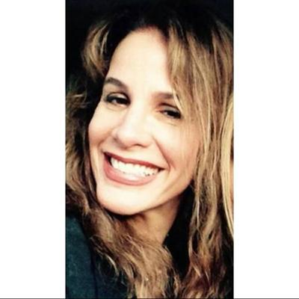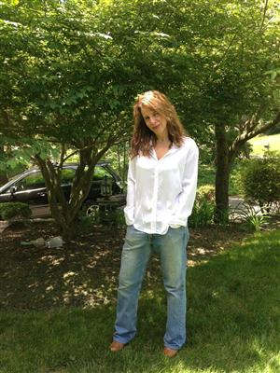

StillSunnySideUp edit your profile
About Photos 25 Settings

- 50 year old woman
- Holland, Pennsylvania, United States
- Seeking Women 47 - 57 within 100 miles of Southampton, Pennsylvania, United States

My details
Relationship:
Never Married
Have kids:
Yes, and they live away from home (2)
Want kids:
No, but it's OK if my partner has kids
Ethnicity:
White / Caucasian No answer
Body type:
Athletic and toned
Height:
5′ 6″
Faith:
Spiritual but not religious
Smoke:
No Way
Drink:
Social Drinker

My headline
Walk with me . . .

In my own words
Hi there. I am a psychologist and so, yes, I would prefer to be listening to you rather than talking about me, but here goes... I have been described as warm, kind, gentle, honest, passionate and funny. I tend to be introspective and "thinking" is one of my favorite things to do. I have an insatiable desire to learn anything and everything (so whatever you do will interest me!). I could spend half the day wandering the aisles of Whole Foods and the other half wandering Barnes and Noble. I enjoy shows including Nashville, Empire, The Mindy Project, Girlfriend's Guide to Divorce, Orange is the New Black and Wentworth. Okay, I admit it . . . I also watch Shameless! I am a very early riser so coffee in the morning is, shall I say, essential! I also enjoy a good Cabernet (not in the morning). My way of being? I am the girl next door type (in a good neighborhood). While low maintenance, I always am well-groomed - I wouldn't dream of going anywhere without my lipstick and I wear sneakers only to run. I enjoy nice things, but am not materialistic. I would take attention over jewelry any day! I am feminine, but not a girly-girl. I will wear both a dress and jeans and get down and dirty in both! I am a positive, happy person, with a playful personality and a strong sense of humor. I have strong moral values. My favorite word very well may be "kindness," and I believe we are here on this earth to portray that. Making a difference in the world is important to me. Some things that I love: a good Cabernet paired with smoked gouda and red grapes; quiet nights at home in front of the fireplace; a warm cup of coffee on a crisp autumn day; the very sight of my puppy; thunder storms, deep conversations, private winks and passionate kissing. Things on my bucket list include traveling to Umbria, Italy; whitewater rafting down the Colorado river; and zip lining in Costa Rica. I'd also like to complete the 50 mile MS bikeathon, learn Italian, win a tango competition, take a figure sculpting class, and see one of my books on the shelf of Barnes and Noble. Oh, and did I mention I would like to end violence and world hunger?! Regarding relationships, I am very loyal and monogamous (the only cheating I ever do involves ice cream). I believe in resolving conflicts civilly, and have an aversion to chaos and drama. I enjoy having an emotionally and physically close relationship, but also need alone time (to do innocent things like write). Regarding my partner, I prefer the company of others who are confident, kind, happy, bright, and intellectually curious. I strive for self-actualization and love when I find that drive in another. As I value health, I prefer women who also enjoy a basic level of fitness (If you know how to make a good smoothie that's a plus! If you run or go to the gym that's a double plus!). Also, I am dedicated to my journey as a spiritually evolving person and would like to find someone who shares that value. If you're atheist or agnostic, we're probably not a good fit. On a final note, I have two daughters who are grown and am looking forward to the next stage of my life. I am hoping you're in a similar place . .

!My interests
Coffee and conversation, Dining out, Movies/Videos, Music and concerts, Exploring new areas, Nightclubs/Dancing, Religion/Spiritual, Travel/Sightseeing, Wine tasting No answer

!Sports & exercise I exercise 5 or more times per week

!Pets
I have cats, and dogs.

!Political views Liberal

!Sign Aries

!Favorite hot spots: Your house and mine . . . ; )

!Favorite things
I enjoy red wine, one-dish meals, soup, ethnic food and chocolate gelato. I like soft rock, CNN, and Showtime. I enjoy hot coffee, warm sweatshirts and aha moments. I like the smell of baked bread, the sight of falling leaves, and the sound of rain

!For fun
I enjoy running, dancing, movies, fine dining, sculpting, reading, writing (books), and people watching. I like picnics, travel, and Broadway musicals. I like deep conversations, candle lit dinners and cozy nights at home in front of the fire.

!Last read
I read books on psychology, spirituality, health and nutrition. I'm presently reading Prosperity by Charles Fillmore. I am always reading A Course in Miracles and, yes, it's all about love versus fear!

!Background/Values

Ethnicity:
White / Caucasian

Faith: Spiritual but not religious

I love God. Kindness is my religion and I live by this. I have strong values. I believe in honesty, love, equality, compassion, unity and service. Mostly, I believe in treating others as I would like to be treated - well!

Languages: English

Education: PhD / Post Doctoral

